DEPARTMENT OF MECHANICAL ENGINEERING
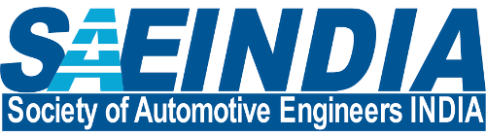
SOCIETY OF AUTOMOTIVE ENGINEERS INDIA
SAE Activities 2019-20

Sr. No. | Title of Activity / Workshop | Resource Person – Name, Designation & Organization | Date Conducted | Target Audience
1. | Design presentation in qualifying round of National event BAJA 2020. | SAE core technical team | 12/07/2019 and 13/06/2019 | Event judged by Technical Experts
2. | Participation in National event BAJA 2020 at Indore. | Entire SAE technical team | 23/01/2020 to 26/01/2020 | Event live on You Tube
3. | Work shop on Solid Works | Alumni of Mechanical Department and ex BAJA team members. | 30/08/2019 and 31/08/2019 | 65 students from SIESGST students from different branches attended the workshop.
4. | Participation in National event ATVC 2020 at Vadodara. | Entire SAE technical team | 15/02/2020 to 19/02/2020 | Expert and other teams
5. | Design War on Solid Works model | SAE team members | 28/09/2019 to 29/09/2019 | Students from SIESGT
6. | Quiz on Automobile | SAE technical team | 28/09/2019 to 29/09/2019 | Students from SIESGT
7. | ATV Drive | SAE technical team | 28/09/2019 to 29/09/2019 | Open to all spectators

~ * ~ * ~

